Week 5 Answers : 27th of April – 1st May
English:
Reading Zone – Unit 27

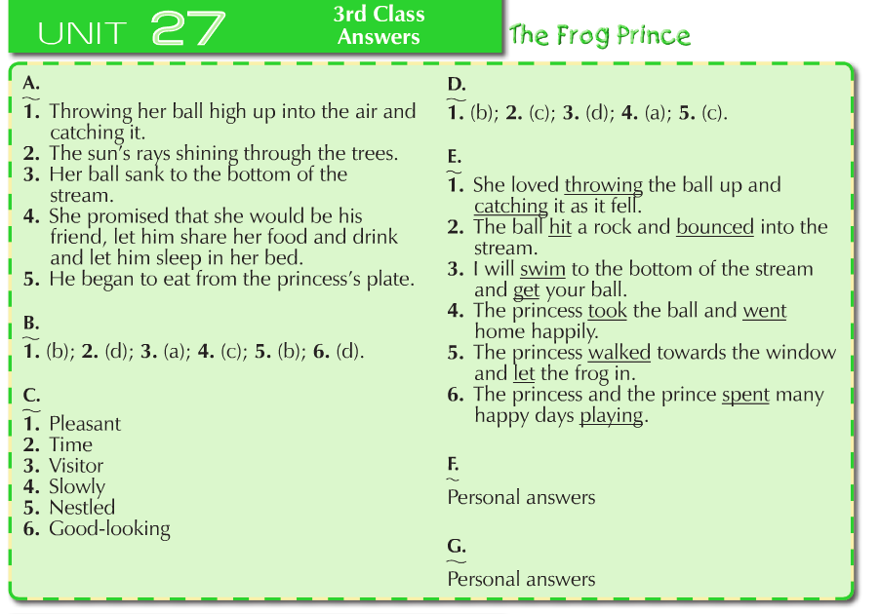
Spellbound Book C – Unit 29
Day
Monday | Tuesday | Wednesday | Thursday
Part A  - hour  - our  - wood  - would  - their  - there  - write  - right  - new  - knew  - won  - our  - hare  - hair  - blew  - blue  Part B  Across  - blue (2)  - one (4)  - wood(6)  - right(7)  - our(9)  Down  - new (1)  - Blew (2)  - one(3  - hour(5)  - hair(8) | Part C - write sentences.  Check for capital letters at the beginning and full stops at the end of every sentence.  Part D  - Blew  - Blue  - hair  - hare  - hour  - knew  - new  - one  - our  - right  - their  - there  - won  - wood  - would  - write. | Part E  - there  - blue  - hare  - one  - would  - wood  - hour  - knew  - right  - our  Part F  Self-correct this section using a dictionary If you can find your word in the dictionary then you are correct | Part G  - hour  - would  - right  - hair  - knew  - their  - blew  - one  Part H  Self-correct this section using a dictionary If you can find your word in the dictionary then you are correct

Maths

Table Toppers 3 - Unit 21

Day & Section | Answers
Monday | Tuesday | Wednesday | Thursday
- (a) 5  (b) 10  - (a) 10  (b)5  (c)0  - (a) 10  (b) 5  (c) 0  - (a)0  (b) 10  (c) 5  - (a) 10  (b) 0  (c) 3  (d) 11  (e)0 | - (a) 1  (b) 2  (c) 3  - (a) 1  (b) 2  (c) 3  - (a) 3,1  (b) 9,3  (c) 6,2  - (a) 2  (b) 3  (c) 10  5. (a) 9  (b) 0  (c)2  (d)6 | - (a) 0,4  (b) 0,6  - (a) 27,9  (b) 33,11  - (a) 4  (b) 9  (c) 6  (d) 11  - (a) 9  (b) 6  5.(a)15  (b)2  (c)6 | - a) 7  (b) 8  (c) 6  (d) 12  - (a) 7  (b) 12  (c) 8  - (a) 10,5  (b) 8,4  (c) 9,3  (d)12,4  - (a) 8  (b) 12  (c)10  (d)7  (e)4

Master Your Maths 3 – Unit 28

Day
Monday | Tuesday | Wednesday | Thursday
Monday  1. 90g  2. Yes  3. 134  4. 4, 6  5. 9  6. 5 to 7  7. 5  8. 390  9. 2⁄10 or 1⁄5  10. 77, 71  11. 5 R2  12. 120  13. 204  14. 7⁄10  15. 5:20  16. 199 | Tuesday  1. 440  2. €1.59  3. 3 x 3  4. 7, 5  5. €2, 50c, 10c, 2c, 2c  6. ----  7. rectangle, circle  8. 335  9. 0.7, 0.6, 0.4  10. 4 R3  11. 24  12. 9  13. €8.70  14. €9  15. €2.10  16. 20 cent | Wednesday  1. 90  2. 7, 6  3. 467cm  4. July  5. 2½, 3, 3½  6. 7 R3  7. 24  8. 5, 9  9. 40  10. 6  11. 2kg 90g  12. 42.3  13. 3⁄4  14. 7:10  15. 141  16. 6 | Thursday  1. 70  2. 750ml  3. 90  4. 55c  5. 6, 12  6. 235  7. 2, 1½, 1  8. 70  9. true  10. 4  11. 6  12. 5kg 805g  13. 3,250ml  14. 1,240ml  15. 1,100ml  16. 4

Gaeilge

Bua na Cainte 3 – Sa Bhaile

Monday –  Page 114 | - D’éirigh sé go moch ar maidin.  - Chuaigh sé isteach sa seomra folctha.  - Nigh sé a aghaidh agus a lámha.  - Scuab sé a fhiacla.  - Chíor sé a chuid gruaige.  - Bhain sé a phitseámaí de.  - Chuir sé a éide scoile air.  - Rith sé síos an staighre ar nós na gaoithe.
Wednesday | - seilide – snail  - droim – back  - teach - house  - spideog – robin  - tor – bush  - uibheacha – eggs  - gor – clocking
Thursday | - Double check all spelling of the poem with your Bua na Cainte book in front of you.

