Week 4 Answers : 20th of April – 24th April

English:

Reading Zone – Unit 26

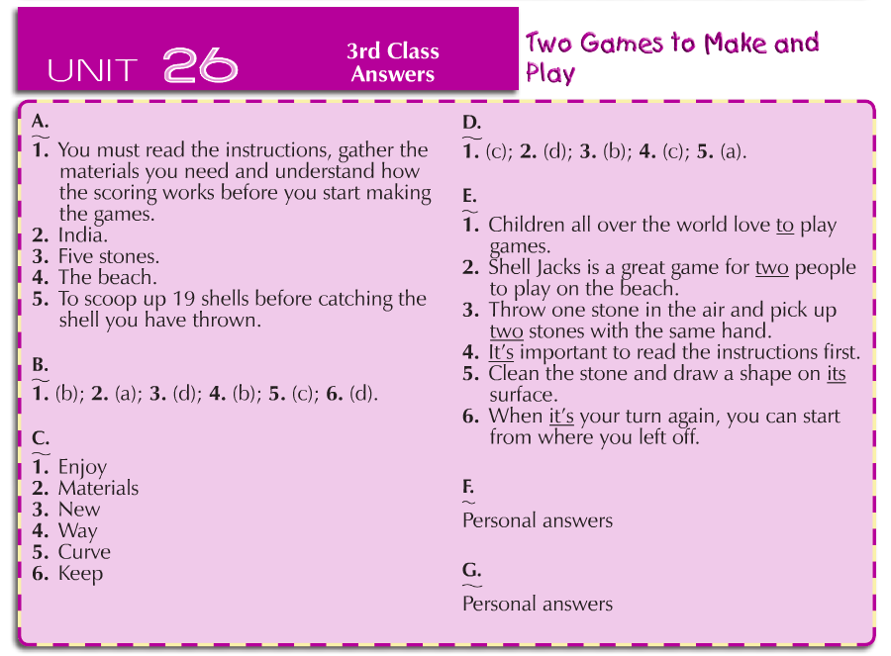

Spellbound Book C – Unit 28

Day
Monday | Tuesday | Wednesday | Thursday
Part A  - Beach  - Boat  - Bucket  - Cave  - Spade  - Seaside  - Seagull  - Tide  - Swimsuit  - Towel  - Sunglasses  - Holidays  - Picnic  - Lifeguard  - Suntan  - Lighthouse  Part B  Across  - Holidays (1)  - Seagull (3)  - Boat (4)  - Towel (7)  - Cave (8)  Down  - Lighthouse (2)  - Bucket (4)  - Spade (5)  Beach (6) | Part C  - Beach  - Boat  - Bucket  - Cave  - Holidays  - Lifeguard  - Lighthouse  - Picnic  - Seagull  - Seaside  - Spade  - Sunglasses  - Suntan  - Swimsuit  - Tide  - Towel  Part D  Self-correct this section using a dictionary If you can find your word in the dictionary then you are correct | Part E  - Picnic  - Spade  - Cave  - Beach  - Towel  - Swimsuit  - Tide  - Seagull  - Lifeguard  - Lighthouse  Part F  Self-correct this section using a dictionary If you can find your word in the dictionary then you are correct | Part G  - Boat  - Cave  - Tide  - Spade  - Bucket  - Beach  - Picnic  - Seagull  - Holidays  - Suntan  Part H  - Swimsuit  - Tide  - Bucket  - Suntan  - Lifeguard  - Picnic  - Beach  - Seaside  - Holidays  - Boat  - Sunglasses  - Towel
Maths

Table Toppers 3 - Unit 19

Day & Section | Answers
Monday | Tuesday | Wednesday | Thursday
- (a) 0, 0  (b) 40, 40  (c) 80, 80  - (a) 5  - (a) 5  (b) 10  (c) 0  - (a) 5  (b) =, 0  (c) 80, ÷  - (a) 11  (b) 3  (c) 5  (d) 5 | - (a) 1  (b) 2  (c) 3  - (a) 8, 8  (b) 24, 24  (c) 16, 16  - (a) 2  (b) 3  (c) 1  (d) 5  (e) 10  - (a) 10  (b) 5  (c) 3  (d) 2  (e) 1 | - (a) 72, 72, 9  (b) 88, 88, 11  - (a) 4  (b) 9  (c) 6  (d) 11  - (a) 4  (b) 9  (c) 11  (d) 6  - (a) 4, 3  (b) 6, 13  (c) 9, 6  (d) 11, 17 | - a) 48  (b) 12  (c) 8  (d) 72  (e) 7  - (a) 56, 56  (b) 96, 96  (c) 64, 64  (d) 72, 72  - (a) 8  (b) 7  (c) 12  - (a) 7  (b) 8  - (a) 21  (b) 3

Master Your Maths 3 – Unit 28

Day
Monday | Tuesday | Wednesday | Thursday
- 90g  - Yes  - 134cm  - 4, 6  - 9  - 5 to 7  - 5  - 390  - $\frac{2}{10}$ or $\frac{1}{5}$  - 77, 71  - 5 r 2  - 120  - 204  - $\frac{7}{10}$  - 5:20  - 199 | - 440  - €1.59  - 3 x 3  - 7, 5  - €2, 50c, 10c, 2c, 2c  - Colour 4 sections  - Circle, rectangle  - 335  - 0.7, 0.6, 0.4  - 4 r 3  - 24  - 9  - €8.70  - €9.00  - €2.10  - 20c | - 90 minutes  - 7, 6  - 467cm  - July  - 2$\frac{1}{2} ,$3, 3$\frac{1}{2} ,$  - 7 r 3  - 24  - 5, 9  - 40  - 6  - 2kg 090g  - 42.3  - $\frac{3}{4}$  - 7:10  - 141  - 6 | - 70  - 750ml  - 90  - 55c  - 6, 12  - 235  - 2, 1$\frac{1}{2} , 1$  - 70  - True  - 4  - 6  - 5kg 805g  - 3l 250ml  - 1l 240ml  - 1l 100ml  - 4 bottles

Gaeilge

Bua na Cainte 3 – Sa Bhaile

Page 110 | - Bhí na páistí thuas staighre.  - Ní raibh na páistí thíos staighre.  - Bhí Bran salach.  - Ní raibh Niamh salach.  - Chuaigh na páistí isteach sa seomra folctha.  - Ní dheachaigh na páistí isteach sa chistin.  - Ní dheachaigh na páistí isteach sa seomra suí.  - Ní dheachaigh na páistí isteach sa seomra leapa.
Page 111 | - Tá leithreas sa seomra folctha.  - Tá cithfholcadh sa chúinne.  - Tá tuáille ar an ráille.  - Tá scáthán/páipéar leithris/ráille ar an mballa.  - Tá páipéar leithreas/báisín níocháin in aice leis an leithreas.  - Tá mata ar an urlár.

