Week 7 Answers : 11th May – 15th May
English:
Reading Zone – Unit 29
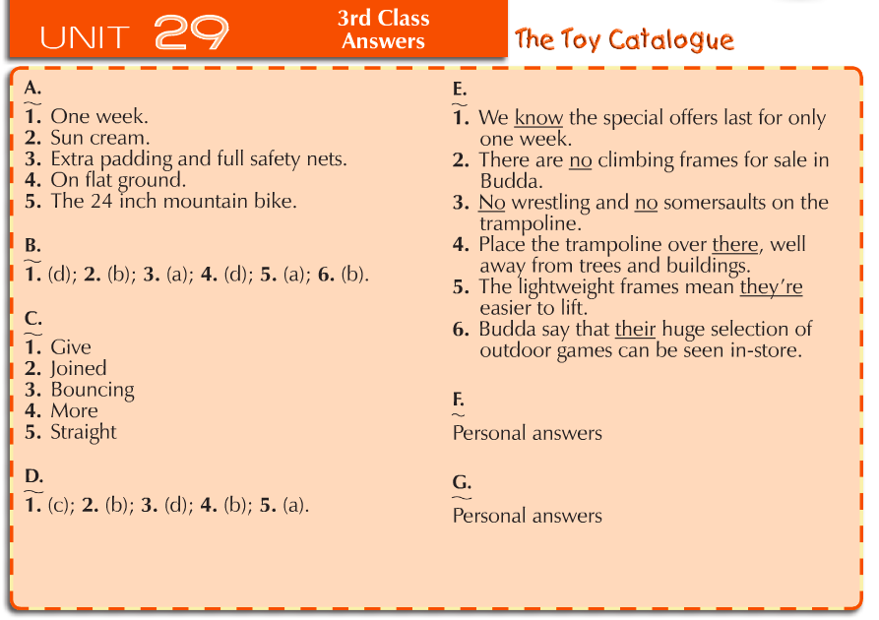
Spellbound Book C – Unit 31
Monday | Tuesday | Wednesday | Thursday
Part A  - Cowboy  - Handbag  - Football  - Goldfish  - Anything  - Bedroom  - Birthday  - Blackbird  - Everyday  - Beehive  - Newspaper  - Homework  - Haircut  - Rainbow  - Pancake  - Raincoat  Part B  Self-correct this section using a dictionary If you can find your word in the dictionary then you are correct | Part C  Across  - Rainbow (2)  - Birthday (5)  - Cowboy (6)  Down  - Haircut (1)  - Bedroom (3)  - Everyday (4)  - Beehive (5)  Part D  Self-correct this section using a dictionary If you can find your word in the dictionary then you are correct | Part E  - Bedroom  - Newspaper  - Pancake  - Birthday  - Football  - Handbag  - Goldfish  - Rainbow  - Anything  - Blackbird  Part F  - Cowboy  - Beehive  - Haircut  - Pancake  - Rainbow  - Football  - Raincoat  - Birthday  - Handbag  - Bedroom | Part G  - Anything  - Bedroom  - Beehive  - Birthday  - Blackbird  - Cowboy  - Everyday  - Football  - Goldfish  - Haircut  - Handbag  - Homework  - Newspaper  - Pancake  - Rainbow  - Raincoat  Part H  - Beehive  - Bedroom  - Handbag  - Raincoat  - Pancake  - Cowboy  - Haircut  - Football  - Goldfish  - Rainbow  - Homework  - Anything
Maths

Table Toppers 3 - Unit 22

Day & Section | Answers
Monday | Tuesday | Wednesday | Thursday
- (a) 0,0  (b) 30,5  (c)60,10  - (a) 0  (b)5  - (a) 5  (b) 0  (c)10  - (a)5  (b) 10  (c) 0  - (a)0  (b) 6  (c) 30 | - (a) 2  (b) 3  (c) 1  - (a) 1  (b) 5  (c) 2  (d)3  - (a)6  (b) 2  (c) 1  - (a) 2  (b) 10  (c) 3  (d)5  (e)1  (f)0  5. (a) 2  (b) 6  (c)3  (d)6 | - (a) 5 (filled in)  (b) 1  (c) 3  (d) 4  (e) 9  (f) 10  - (a)11  (b) 6  (c)4  - (a) 9  (b) 6  (c) 11  (d) 4  - (a) 4  (b) 11  (c)36  (d)9 | - a) 2  (b) 7  (c) 72  (d) 6  - (a) 7  (b) 3  (c) 8  (d)12  (e)10  - (a) 36  (b) 48  (c) 60  - (a) 8  (b) 7

Maths

Master Your Maths 3 – Tests 2 – 5

Day
Test 2 | Test 3 | Test 4 | Test 5
1. 16  2. 9  3. 4  4. minute hand pointing at two and hour hand just after seven.  5. 8  6. 125  7.  8. 20  9. 11  10. 55c  11. 14  12. 10  13. 59  14. 32  15. 20, 40  16. 55cm  17. 1kg  18. 1h 3t 6u  19. 8  20. 20c, 20c, 5c, 2c, 1c  21. 22  22. 13  23. 24  24. 40  25. 80 | 1. 8  2. 18  3. 4  4. 16  5. 10  6. 3  7. minute hand pointing at two and hour hand just after nine.  8. 179  9. 12  10. cuboid  11. <  12. 85  13.  14. 16  15. 36  16. 2  17. 50c, 20c, 10c, 5c  18. 4h 3t 7u  19. 298  20. 1000ml  21. 40  22. 8  23. 48  24. 31c  25. 23 | 1. 15  2. 5  3. 28, 36  4. 20  5. 293  6. 14  7. 20  8. 34  9. 356  10. 300  11. sphere  12. 187  13. possible  14. 11, 13, 15  15. 4t 8u  16. 400g  17. <  18. 635  19. 500ml  20. 50c, 20c, 5c, 2c, 1c  21. 3  22. 28c  23. 3  24. 1m 12cm  25. 16km | 1. 50  2. 32  3. 16  4. 7t 3u = 73  5. 500  6. 24  7. 20  8. 45  9. 40, 30, 25  10. 30  11. 12  12. 85  13. 50c, 20c, 5c  14. 6cm  15. 550g  16. sphere  17. 673  18. 9  19. 8  20. 16  21. €65  22. 48  23. 7  24. 27  25. 133

Gaeilge
Bua na Cainte 3 – Sa Bhaile

Page 120 – Monday | - Pian – Pain  - Bolg – stomach  - Aréir – last night  - Chodail – sleep  - Fios – to seek out, knowledge  - Scrúdaigh – examine  - Leigheas – medicine  - Biseach – improvement or recovery
Pg. 120 – Tuesday | - Bhí Ciara tinn.  - Bhí pian ag Ciara.  - Níor chodail sí i rith na hoíche.  - D’fhán Mamó léi.  - Níor fhan Niamh léi.  - Chuir Mamó fios ar an dochtúir.  - Tháinig an dochtúir.  - Scrúdaigh an dochtúir Ciara.  - Níor scrúdaigh an dochtúir Mamó.  - Bhí biseach uirthi go luath.
Pg. 121 – Thursday | - D’fhan Mamó agus na páistí sa bhaile inné.  Fanann Mamó agus na páistí sa bhaile gach lá.  Fanfaidh Mamó agus na páistí sa bhaile amárach.  - Fanfaidh Mamó agus na páistí sa bhaile amárach.  D’fhan Mamó agus na páistí sa bhaile inné.  Fanann Mamó agus na páistí sa bhaile gach lá.  - D’fhág Mamó an mála mór milseán ar an mbord inné.  Fágfaidh Mamó an mála mór milseán ar an mbord amárach.  Fágann Mamó an mála mór milseán ar an mbord gach lá.  - Fágfaidh Mamó an mála mór milseán ar an mbord amárach.  D’fhág Mamó an mála mór milseán ar an mbord inné.  Fágann Mamó an mála mór milseán ar an mbord gach lá.  - D’fhéach na páistí ar an teilifís inné.  Féachann na páistí ar an teilifís gach lá.  Féachfaidh na páistí an teilifís amárach.

