Week 8 Answers : 18th May – 22nd May
English:
Reading Zone – Unit 30
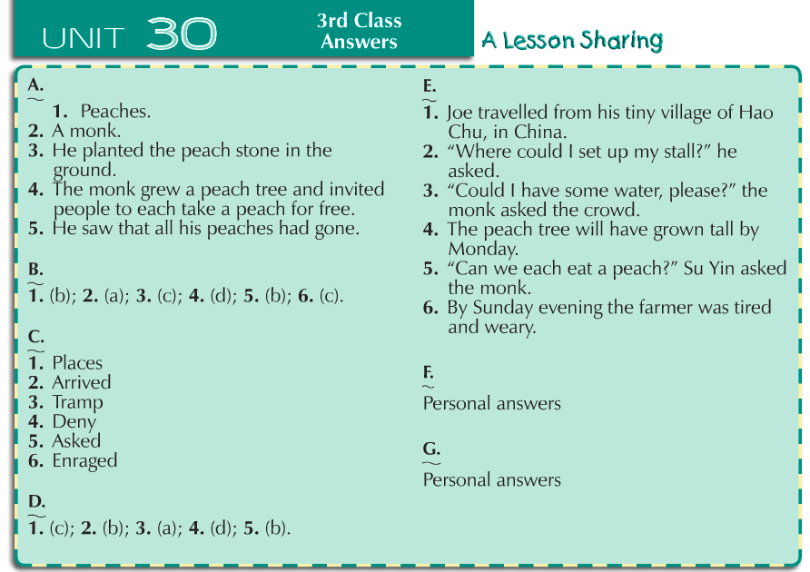

Spellbound Book C – Unit 32
Monday | Tuesday | Wednesday | Thursday
Part A  Words appear in the same order as in the boxes at the top.  Part B  - Amount  - Double  - Lovely  - Biscuit  - Guest  - Piece  - Attack  - Sense  - Minute  - answer | Part C  Self-correct this section using a dictionary If you can find your word in the dictionary then you are correct  Part D  Self-correct this section using a dictionary If you can find your word in the dictionary then you are correct | Part E  Across  - answer (1)  - piece (5)  - potato (8)  - Biscuit(9)  Down  - Senses(2)  - Nephew(3)  - Guest(4)  - Attack(6)  - Minute(7)  Part F  Incorrest spellings are the following numbers:  1,4,6,7,9,12,14,16 | Part G  - surprise  - enough  - guest  - potato  - already  - answer  - licence  - sense

Maths - Table Toppers 3 - Unit 23
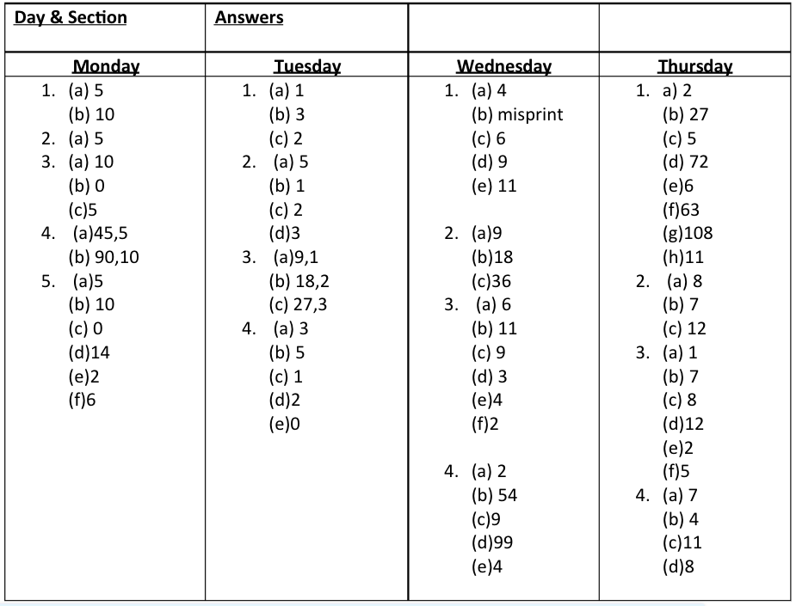

Maths - Master Your Maths Test 25
Day
Test 6 | Test 7 | Test 8 | Test 9
1. 79  2. 38  3. 4h  4. 50, 80  5. 200  6. 32  7. colour 5 apples  8. 121  9. 20 to 5  10. cone  11. €1.75  12. 28  13. <  14. 300  15. 6  16. Yes  17.  18. 20  19. 124  20. 500ml  21. 85  22. 2001  23. 31c  24. 1 hour 15 minutes  25. 7 | 1. 54  2. 45  3. 8  4. 6h 0t 5u  5. 17  6. 106  7. 6  8. 10  9. 7:45  10. 2h 3t 5u  11. 5h  12. €2, €1, 50c, 2c, 1c  13. 12, 18  14. 4cm  15. b  16. 5  17. 950ml  18. 25  19. 68  20. 16  21. 24  22. 70c  23. 36  24. 1 hour 15 minutes  25. 1m 25cm | 1. 77  2. 41  3. 7h 8t 3u  4. 500  5. 16  6. 30  7. draw a hexagon  8. 47  9. €2, 50c, 10c, 2c, 2c  10. 114  11. 10 to 7  12. 30  13. 20  14. 324  15. 29  16. September  17. 4  18. 24, 18  19. 4cm  20. <  21. 92  22. 32c  23. 11  24. 208  25. 8:00 | 1. 63  2. 42  3. 19  4. 12  5. 12  6. 3u  7. 4h 6t 7u  8. No  9. cone  10. September  11. 50c, 20c, 20c, 2c, 1c  12. Yes  13. colour 5 lemons  14. 10  15. 334  16. 135  17. 21, 23, 25  18. minute hand (longer hand) at 9 and hour hand close to 10.  19. 465g  20. 330ml  21. 114  22. 25  23. 40  24. 70c  25. 2m 70cm

Gaeilge - Bua na Cainte 3 – An Teilifís
Page 124  Translate | - Sa chúinne – in the corner  - Lampa - lamp  - Pictiúr - picture  - Cuirtíní - curtains  - Ar an tolg – on the sofa  - Dallóg - blinds  - Ríomhaire - computer  - Teilifís – T.V.  - Ar an bhfuinneog – on the window  - Ar crochadh ar an mballa – hanging on the wall  - Scáthán - mirror  - Os cionn na tine – above the fire  - Ar an matal – on the mantlepiece  - Grianghraf - photograph  - Tine - fire  - Os comhair an tine – in front of the fire  - Ar an mata – on the mat  - Tinteán - fireplace  - Ar an gcathaoir uilleach – on the armchair
Pg. 124  Questions | - Tá Daidí ina shuí ar an gcathaoir uilleach.  - Tá Oisín ina shuí ar an tolg.  - Tá tine sa tinteán.  - Tá Bran ar an mata.  - Tá an grianghraf ar an matal.  - Tá an pictiúr ar crochadh ar an mballa.  - Tá an scáthán os cionn na tine.  - Tá an clog ar an matal.  - Tá na cuirtíní ar an bhfuinneog.  - Tá an dallóg ar an bhfuinneog.
Pg. 125 | - Tháinig an sorcas  - Chuaigh Ciara go dtí an sorcas.  - Chuaigh Roisín go dtí an sorcas.  - Chonaic said capaill ag damhsa.  - Bhí an madra ag seinm veidhlín.  - Bhí an moncaí gléasta mar gharda.  - Bhí bríste ar an gcat.  - Bhí an luch ag marcaíocht ar an mhuc.  - Bhí an t-asal ag canadh.  - Thaithin an sorcas go mór leis na páistí.
Translations | Ag seinm – playing  Veidhlín – violin  Bríste – trousers  Srón – nose  Ag marcaíocht – riding  Muc - pig

